**Learning Assignment:**

**Inheritance:**

The method of inheriting the properties of parent class into a child class is known as inheritance.

**Benefits of Inheritance:**

1. Code reusability- we do not have to write the same code again and again, we can just inherit the properties we need in a child class.
2. It represents a real world relationship between parent class and child class.
3. It is transitive in nature. If a child class inherits properties from a parent class, then all other sub-classes of the child class will also inherit the properties of the parent class.

**Example:**

Here is the simple example of inheritance:

**Code:**

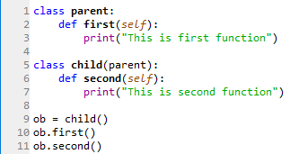

**Output:**

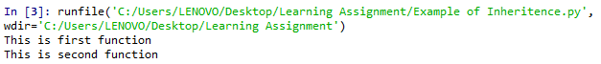

**Types of Inheritance:**

1. Single
2. Multiple
3. Multilevel
4. Hierarchical
5. **Single Inheritance:**

When a child class inherits only a single parent class.

**Example:**

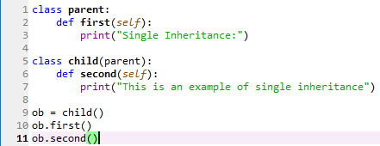

**Output:**



1. **Multiple Inheritance:**

When a child class inherits from more than one parent class.

**Example:**

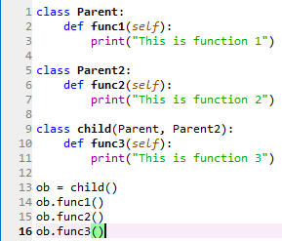

**Output:**

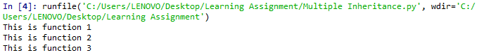

1. **Multilevel Inheritance:**

When a child class becomes a parent class for another child class.

**Example:**

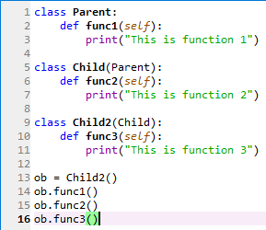

**Output:**

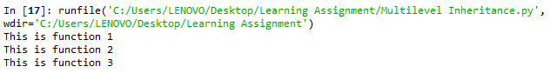

1. **Hierarchical Inheritance:**

Hierarchical inheritance involves multiple inheritance from the same base or parent class.

**Example:**

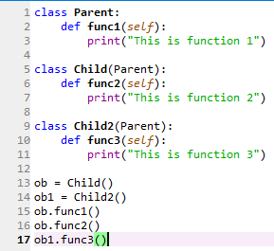

**Output:**

